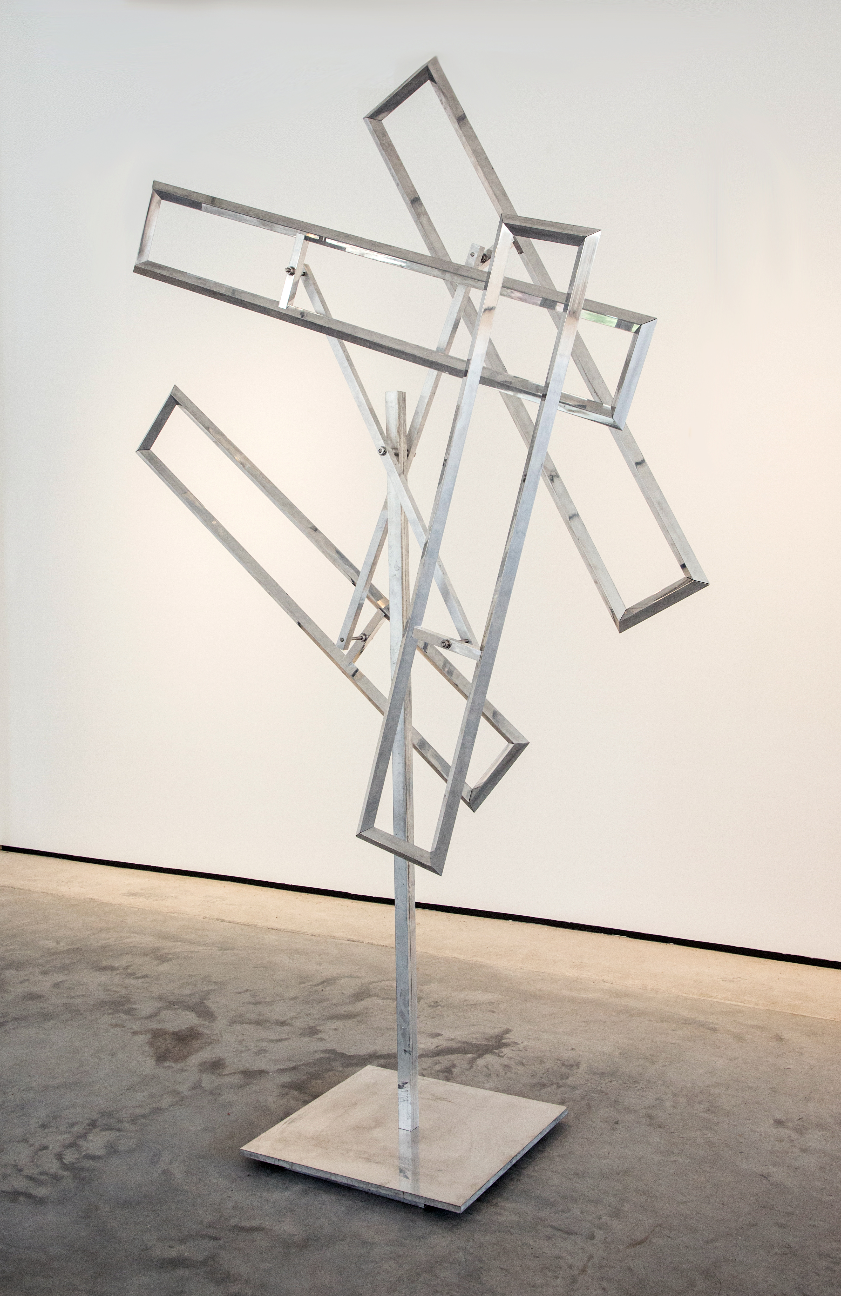
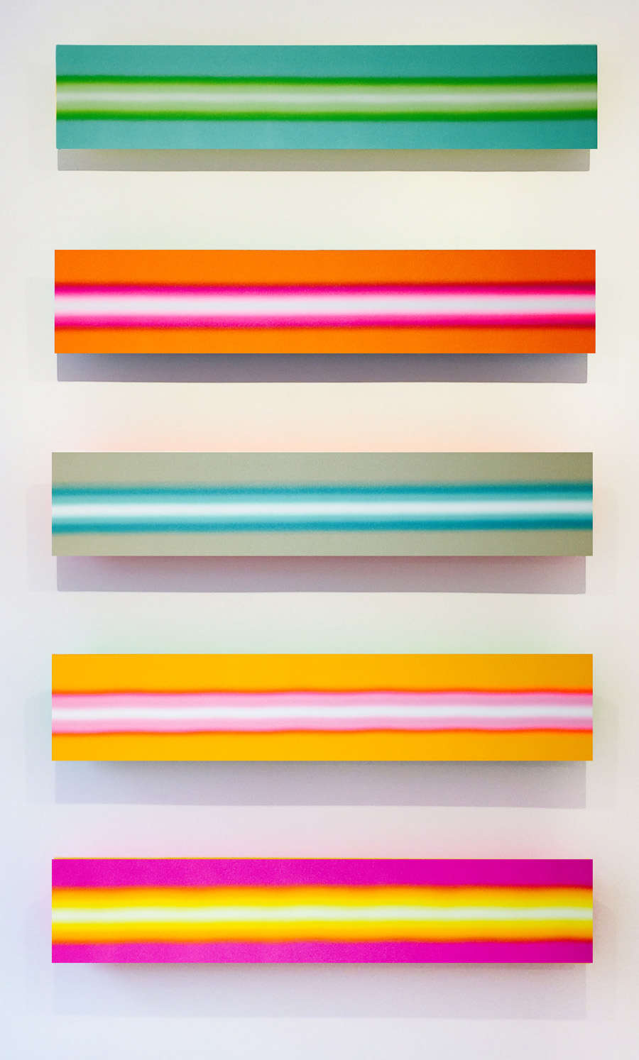

FOR IMMEDIATE RELEASE
Jerry Cabrera and John Poché
August 1 – September 12, 2020
Exhibition Opening: Saturday, August 1, 10am – 6pm
during White Linen Light in the Arts District New Orleans
Octavia Art Gallery is pleased to present an exhibition of recent light paintings by Jerry Cabrera and kinetic sculptures by John Poché.
Jerry Cabrera’s Light Painting series captures the preciousness and sacredness of light through his glowing and vibrant rectangular canvasses. Although abstract, Cabrera’s stacked canvases give the viewer a visual escape and create the sensation of looking at a sunset or gazing through an open window from a dark place. Cabrera’s intent with these paintings is to, “give the viewer a narrow but vast window of light. Narrow enough not to physically fit through, but vast enough through which to visually escape.”
John Poché’s most recent body of polished aluminum and stainless steel kinetic sculptures includes both large-scale outdoor pieces as well as smaller indoor works. Many of the indoor pieces come with his latest innovation of custom designed and built pedestals, which include computerized fans that propel the work randomly and silently indoors. Poché’s elegant sculptures are a combination of traditional metalworking techniques alongside cutting-edge software technologies, a synthesis he has spent years studying and refining. The artist says, “Each work is unique, but the real wonder of kinetic sculpture is the constant motion that keeps the pieces from ever appearing the same. There are limitless looks and positions for every rotating element.”
Cabrera lives and works in San Antonio, TX. He received his Bachelor of Fine Arts degree from Texas State University and his Master of Fine Arts degree from the University of Texas at San Antonio. Cabrera has exhibited nationally, and his work is included in several prominent collections, including Neiman-Marcus and the AT&T Center.
Poché is a New Orleans based artist who graduated from Tulane University. Previously he worked in radio, built and owned a broadcast software company and managed software divisions for Arbitron Inc. and Clear Channel Radio. Poché’s work has been exhibited in Chicago as well as in New Orleans during both Art For Arts’ Sake and Luna Fete.

