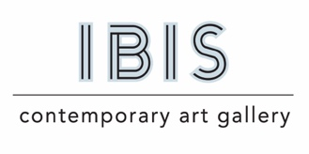
Press Release:
For Immediate Release
Contact: Margaret Davis
734.476.7918
margaretdavis@ibisartgallery.com

New Exhibition: Lisa Krannichfeld, Taking Up Space

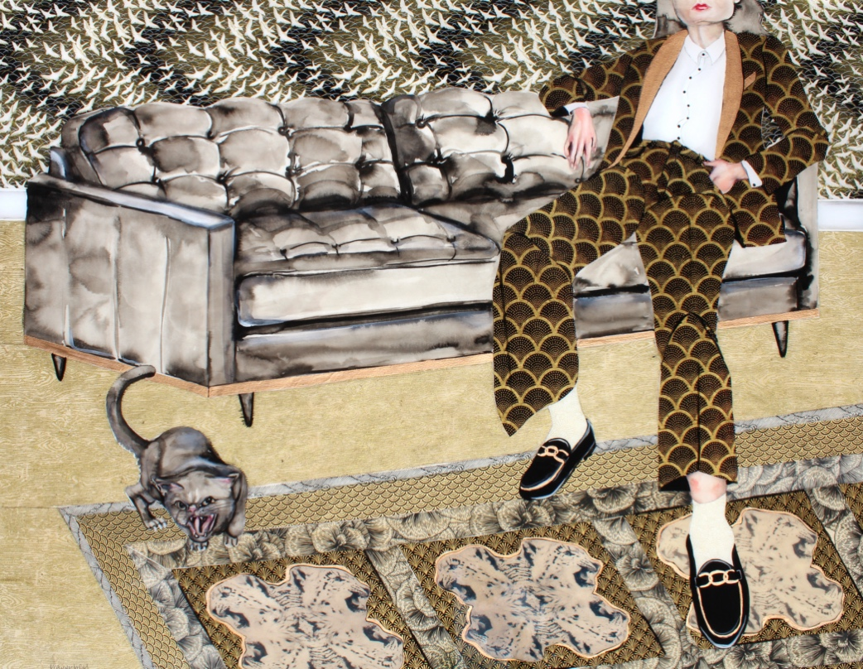
Dominion (in Black and Gold), 2022, ink, watercolor, acrylic, paper collage, cyanotype, and resin on watercolor paper, mounted on cradled wood panel, 33 x 42in.

New Orleans, LA – IBIS Contemporary Art Gallery is pleased to announce the upcoming solo exhibition by Lisa Krannichfeld, Taking Up Space. The exhibition opens May 6th through June 24th with an Artist’s Reception on May 6th, 5-9 pm in conjunction with Arts District of New Orleans’ Jammin’ on Julia The installation will include more than 10 boldly composed mixed-media works.

In this series of figurative works Krannichfeld presents a highly expressive view of powerful women through materials and composition. Maximalist in nature, these works are composed of a wide range of media, including, ink, watercolor, acrylic, collage, cyanotypes, and resin. The complex use of materials composing the figures is metaphor for the emotional state of women amidst the seemingly unending struggle for equality, bodily autonomy, and the of validity of women’s experience. While women’s sovereignty over their lives and bodies seems to dwindle in global society, the figures in these works own and command the space in the compositions with an indisputable sense of authority; a cathartic push for life to imitate art. The larger-than-life scale, confrontational gestures, and clothing details all serve as windows into the figures’ psyches, without the need for a fully visible face. With the absence of individual identity, the figures in the paintings represent all people who desire to take up more space and gain more autonomy in their lives, countering forces around them that may say otherwise.

Lisa Krannichfeld is a multi-media figurative artist from Little Rock, AR. She received her BA from Colorado College and Master’s of Education from the University of Arkansas at Little Rock. She has exhibited work around the United States, parts of Europe, Australia, and Asia. Her work belongs to collections including the Arkansas Museum of Fine Arts, The Historic Arkansas Museum, Hot Springs National Park, The Bennett Collection, The Argenta Mural Project, and The Oz Collection. Her work has received numerous juried art awards including the Grand Award in the 60th Delta Exhibition at the Arkansas Museum of Fine Arts.

