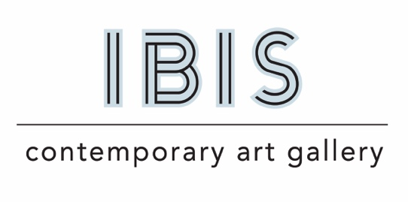

Press Release:
For Immediate Release
Contact: Margaret Davis
734.476.7918
margaretdavis@ibisartgallery.com

MARGARET DAVIS NAVIGATING

Contemporary realist and figurative painter, Margaret Davis, focuses on portraying adolescents — an age characterized by profound brain growth, idealism, and plasticity. Her artworks offer visual responses to the cultural and political challenges that Gen Z has had to navigate.
Davis employs a distinctive layered technique in her paintings. The first layers are mixed media, incorporating transfers, spray paint, and screen prints. A layer of clear or toned resin is then poured over these images, producing a translucent effect. This underlying imagery is often taken from or relates to the teen’s environment. The figures within her pieces are developed with oil paint, at times realistically and at other times just emerging from their background. Amidst the figures, both tangible and illusory barriers populate the exhibition, along with symbols of optimism such as life preservers and buoys.

For Davis, many of the paintings act as storyboards – ideas for a narrative not yet chronicled.

Margaret Davis, lives and works in New Orleans where she recently opened and co-directs IBIS Contemporary Art Gallery.

“I'm truly excited about presenting my work in New Orleans for the first time. Being a part of IBIS Contemporary Art Gallery and co-directing it in this vibrant city has been an incredible journey. I'm looking forward to sharing my work with the local community and engaging with the dynamic art scene that New Orleans offers.”

She is a Professor Emeritus from Eastern Michigan University, where she taught Painting and Drawing for 25 years. A native of Perrysburg, Ohio, Davis earned her BFA in Sculpture from Boston University's College of the Arts and her MFA in Painting from The University of Michigan.

One and two-person exhibitions include Ibis Contemporary Art Gallery in New Orleans, LA; Buckham Gallery in Flint, MI; The Duderstadt Center Gallery at The University of Michigan; The Kreft Gallery at Concordia University, Ann Arbor, MI; Karnataka Chitrakala Parishath Art School in Bangalore, India; Rosewood Arts Center in Kettering, Ohio; 20 North Gallery in Toledo, Ohio; Detroit Street Gallery in Ann Arbor, Michigan; and River Gallery in Chelsea, Michigan.

Navigating opens September 2nd and runs through October 28th with an Artist’s Reception September 2nd, 5:00 – 9:00 pm.

